Grog Basic  - 1.5 oz rum  - 4 oz water  Grog Fancy  - 1.5 oz rum  - 4 oz soda  - Juice of 1 lime  Grog and Stormy  - 1.5 oz rum  - 4 oz ginger beer  - Juice of 1 lime  - 3 drops angostura bitters | Complicated, I know  Questions:  Ask which version they’d like.  The basic is very basic but kind of refreshing. Kind of alcoholic water.  The fancy is a little more challenging but more traditionally cocktail coded.  The grog and storm is just a dark and stormy.  Directions:  Build in tall glass filled with ice. Stir.
Mai Tai  - 1 oz 151 Rum  - 1 oz White Rum  - 0.5 oz Dry Curacao  - 0.75 oz Orgeat  - Juice of one lime  - 0.5 oz Grenadine  Notes:  Warn people this is a stronger drink | Variants:  For a less sweet drink, the grenadine can be substituted for 0.25 oz simple and 5+ dashes of angostura bitters  Directions:  Combine all into a shaker with ice and shake vigorously. Free pour into tiki mug if available, otherwise a pint glass. Top with ice
Jolly Java (Tiki Espresso Martini)  - 1 oz cold brew  - 1 oz aged rum  - 1 oz white rum  - 0.5 oz orgeat  - 0.5 oz falernum  - 2 dash angostura bitters | Directions:  Combine all in a shaker filled with ice. Shark hard and strain into a low glass filled with ice.
Mojito  - 2 oz white rum  - 1 oz simple syrup  - Juice of 1 lime  - Handful of mint  - Top with soda water | Directions:  Muddle lime in a shaker. Add rum, sugar, and lime. Fill shaker with ice and shake vigorously. Strain into a tall glass filled with ice and top with soda. Stir and serve.  Can sub vodka or tequila as needed
Mommy’s Medicine (Painkiller)  - 3 oz Mommy’s Medicine (Rum Mix)  - 4 oz pineapple juice  - 1 oz orange juice  - 1 oz coconut cream  - Nutmeg (garnish)  Notes:  Warn people this is a very strong drink | Directions:  Put all ingredients (except nutmeg) into a shaker filled with ice. Shake hard, then strain into a tall glass filled with ice. Garnish with fresh nutmeg (actually important!)  Mods:  This should be fine with less rum  Rum Mix (for reference)  1 oz Kracken; 1 oz white rum; 0.5 oz pot still rum; 0.5 oz 151
Pea in the Pool  - 1. 5 oz lemon juice  - 1.25 oz simple syrup  - 2 oz butterfly pea vodka or gin  Notes:  This drink changes colors when the pea and acid mix. For a more “fun” version, mix the lemon and sugar in a separate glass and reverse the layering. (pea first, then pour the lemon+sugar) | Questions:  Vodka or gin?  Directions:  Combine lemon and simple in a low CLEAR glass filled with ice. Pour butterfly liquor over the back of a bar spoon to layer the liquor. Include something to stir with to induce color change and make drinkable.  (see reference photos)
Highball  - 1.5 oz liquor  - Fill soda  Notes:  This is a simple, uncomplicated drink that can really hit the spot. It is not “good” by the traditional measure. Can be made weaker or stronger to taste. | Questions:  What liquor? Rum, tequila, vodka, or whiskey?  Directions:  Add liquor to tall glass filled with ice. Top with soda. Stir.
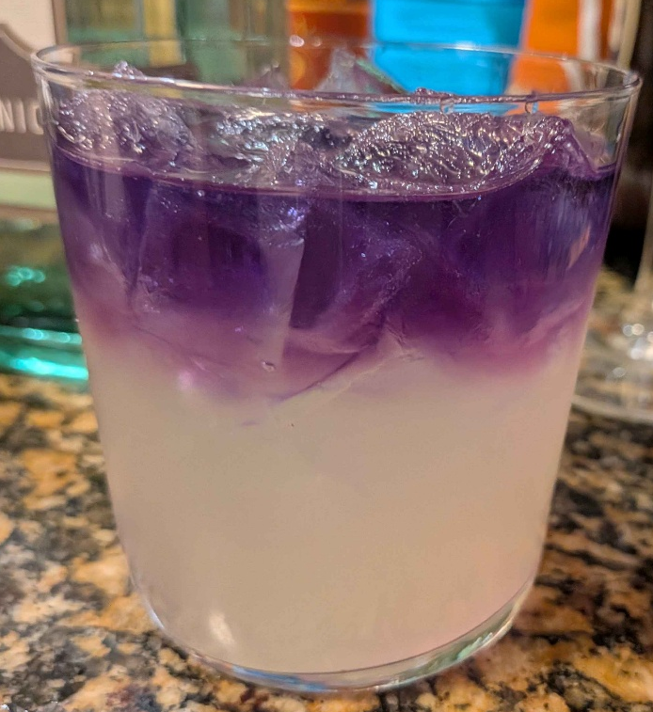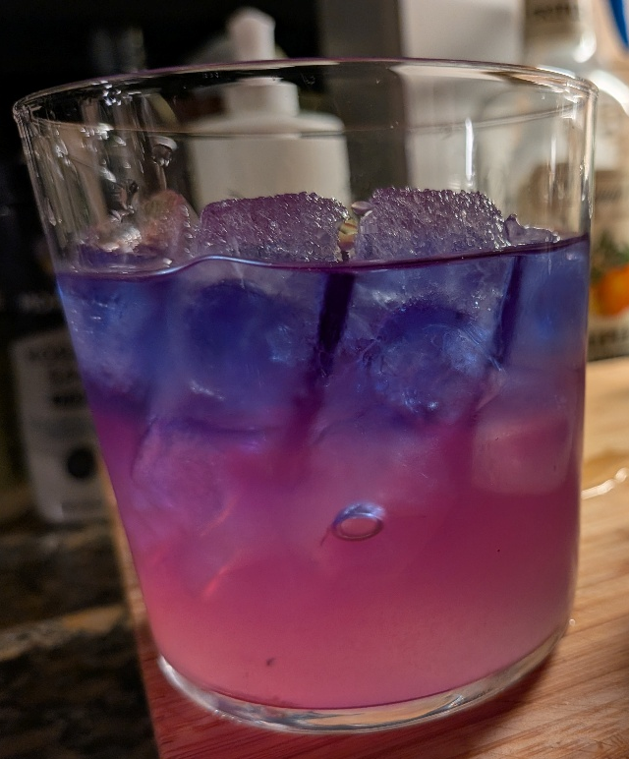
NORMAL PEA Backwards/Bisexual

